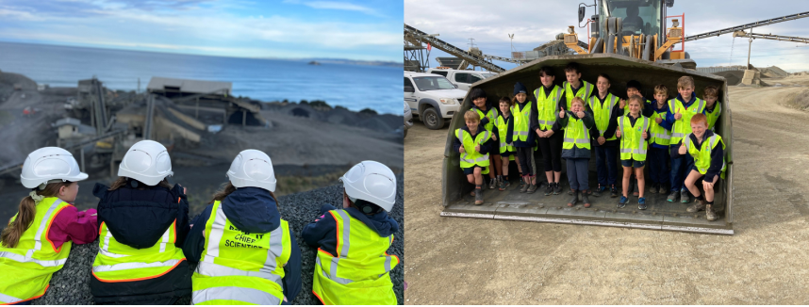

📝 Entry form 2026

Name of school: ……………………………………………………………………………………………….........

Contact person: ……………………………………………………………………………………………...……...

Contact details (email, phone): …………………………………………………………………………………..
Name of quarry visited: ……………………………………………………………………………………………
Student names: ……………………………………………………………………………... Year: 5 6 7 8

…………………………………………………………………………………………………………………………..

…………………………………………………………………………………………………………………………..

…………………………………………………………………………………………………………………………..

…………………………………………………………………………………………………………………………..

…………………………………………………………………………………………………………………………..

…………………………………………………………………………………………………………………………..

…………………………………………………………………………………………………………………………..

…………………………………………………………………………………………………………………………..

How did you hear about this competition?.............................................................................................

Please return this form and entries to office@aqa.org.nz before the end of Term 3,
Friday 25th September 2026.

